Broadbent, David (Notes mainly from a Busselton Dunsborough Times report)
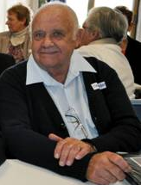
Dave Broadbent at the 2013 Forestry Reunion.
David’s father Joseph worked in forestry for 10 years, his brothers Chris and Charles both worked in the field for over 40 years, and David has worked in the southern forests for more than 45 years.

